## Dataset: <https://www.kaggle.com/datasets/iamsouravbanerjee/women-empowerment-index>

# Dataset Overview:

The Women Empowerment Index (WEI) is a multifaceted tool designed to assess and track the progress of women's empowerment within societies. Drawing from diverse metrics and indicators, the WEI offers a nuanced understanding of the status of women across various domains. It builds upon the foundation laid by existing indices like the Gender Inequality Index (GII) but focuses specifically on aspects related to women's empowerment. The WEI encompasses several key dimensions, including economic participation, political representation, access to education and healthcare, and social

inclusivity. By analyzing these dimensions, the index sheds light on the extent to which women are able to exercise agency, access resources, and participate fully in societal processes.

# Column Descriptions:

1. **Country:** The name of the country or territory included in the dataset.
2. **Women's Empowerment Index (WEI) - 2022:** Quantifies women's empowerment within each country for the year 2022, offering insights into gender dynamics and opportunities for women.
3. **Women's Empowerment Group - 2022:** Categorizes countries based on their performance and status regarding women's empowerment, facilitating comparative analysis.
4. **Global Gender Parity Index (GGPI) - 2022:** Measures gender parity at a global level for the year 2022, indicating the degree of equality between men and

women.

1. **Gender Parity Group - 2022:** Classifies countries into groups based on their level of gender parity, aiding in the identification of trends and disparities.
2. **Human Development Group - 2021:** Classifies countries into specific groups based on their Human Development Index (HDI) scores and development levels for the year 2021.
3. **Sustainable Development Goal regions:** Aligns countries with specific regions as defined by the Sustainable Development Goals (SDGs), providing context for development efforts and initiatives.

# Charts:

## Avg. WEI by Region & Dev. Group (2022):

* 1. **Chart:**

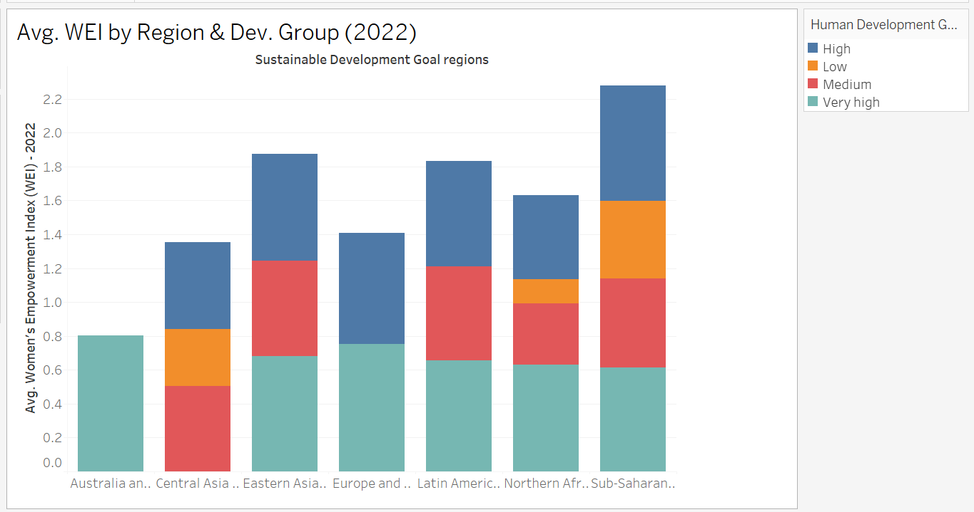

## Observations:

* + - **Regional Disparities in Women's Empowerment:** The chart reveals significant differences in the average WEI across various regions. While regions like Eastern Asia and South-Eastern Asia exhibit higher WEI scores, indicating greater progress in women's empowerment, regions like Sub-Saharan Africa and Northern Africa show lower scores, suggesting challenges in these areas.
    - **Correlation with Human Development:** There seems to be a positive correlation between the Human Development Group of a region and its average WEI. Regions with higher Human

Development Groups, such as Europe and North America, tend to have higher WEI scores, suggesting that overall development progress is often linked to advancements in women's empowerment.

* + - **Need for Targeted Interventions:** The chart highlights the need for targeted interventions to address the specific challenges faced by regions with lower WEI scores. Strategies should be tailored to the unique socio-cultural and economic contexts of these regions to promote women's empowerment effectively.

## WEI by Gender Parity Group (2022):

* 1. **Chart:**

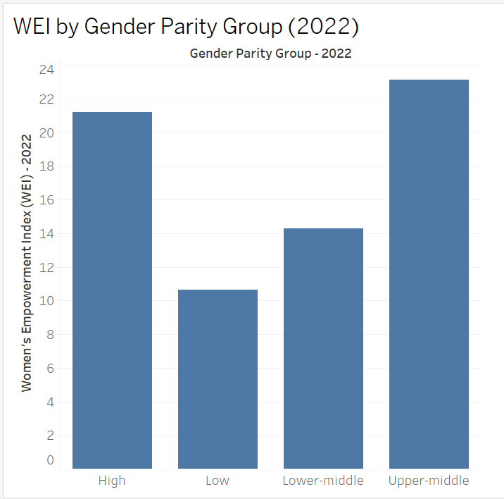

## Observations:

* + - **Gender Parity and Women's Empowerment:** The chart illustrates a positive correlation between gender parity and women's empowerment. Countries with higher gender parity (High) generally have higher WEI scores, indicating greater progress in women's empowerment. Conversely, countries with lower gender parity (Low and Lower-middle) tend to have lower WEI scores.
    - **Need for Addressing Gender Disparities:** The chart highlights the importance of addressing gender disparities across various domains. Countries with lower gender parity need to focus on policies and initiatives that promote gender equality and empower women to participate fully in society.
    - **Room for Improvement in High-Parity Countries:** While countries with high gender parity have made significant progress, the chart suggests that there is still room for improvement. Even in these countries, efforts should be made to address remaining gender gaps and ensure that women have equal opportunities in all aspects of life.

## Countries by Women's Empowerment Group - 2022:

* 1. **Chart:**

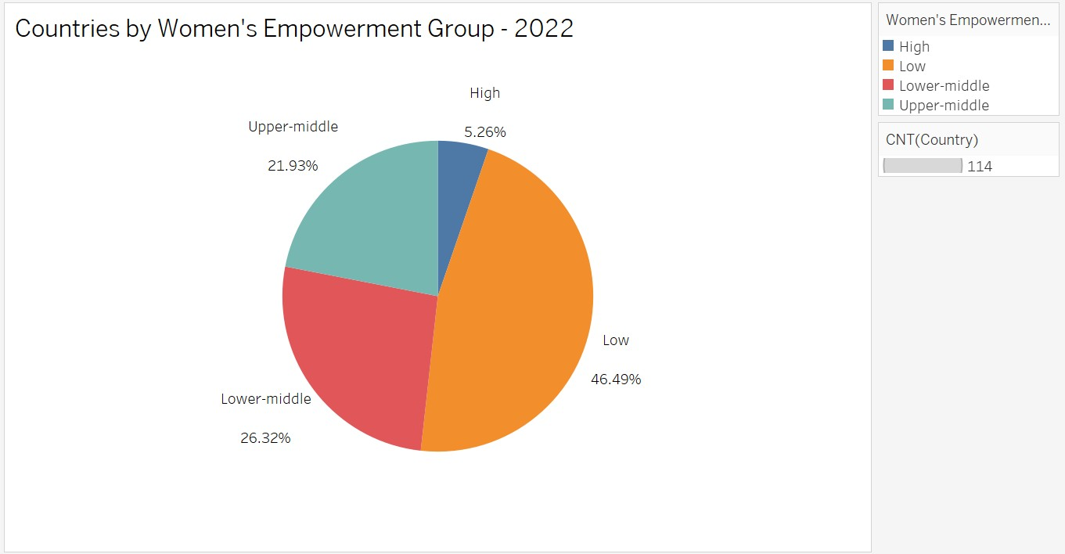

## Observations:

* + - **Dominance of Lower-Middle Group:** The chart shows that the majority of countries fall into the Lower-Middle category for

women's empowerment. This indicates that many countries have moderate levels of women's empowerment and require further efforts to improve.

* + - **Limited Number of High-Empowerment Countries:** The High category represents a relatively small proportion of countries, suggesting that achieving high levels of women's empowerment is challenging for many nations. This highlights the need for targeted interventions and policy changes to promote women's empowerment globally.
    - **Distribution across Groups:** The distribution of countries across the different empowerment groups provides insights into the global landscape of women's empowerment. Understanding the specific challenges faced by countries in each group can inform the development of effective strategies to advance women's rights and opportunities.

## Top 5 Countries by WEI:

* 1. **Chart:**

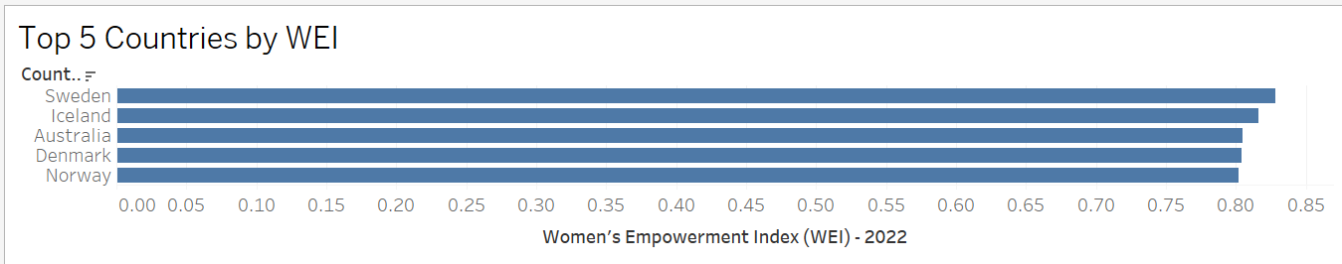

## Observations:

* + - **Nordic Countries Dominance:** The chart highlights the dominance of Nordic countries in terms of women's empowerment. Sweden, Iceland, Denmark, and Norway consistently rank among the top five countries with the highest WEI scores. This suggests that these countries have implemented effective policies and social structures that promote gender equality and empower women.
    - **Regional Disparities:** The concentration of top-ranking countries in the Nordic region indicates significant regional disparities in

women's empowerment. This highlights the need for global efforts to address these disparities and promote women's rights and opportunities in all regions.

* + - **Lessons from High-Performing Countries:** The success of

Nordic countries in achieving high levels of women's empowerment can provide valuable lessons for other nations. Analyzing their policies, social norms, and cultural practices can help identify best practices and strategies for promoting gender equality and women's empowerment.

## Comparison of WEI and GGPI:

* 1. **Chart:**

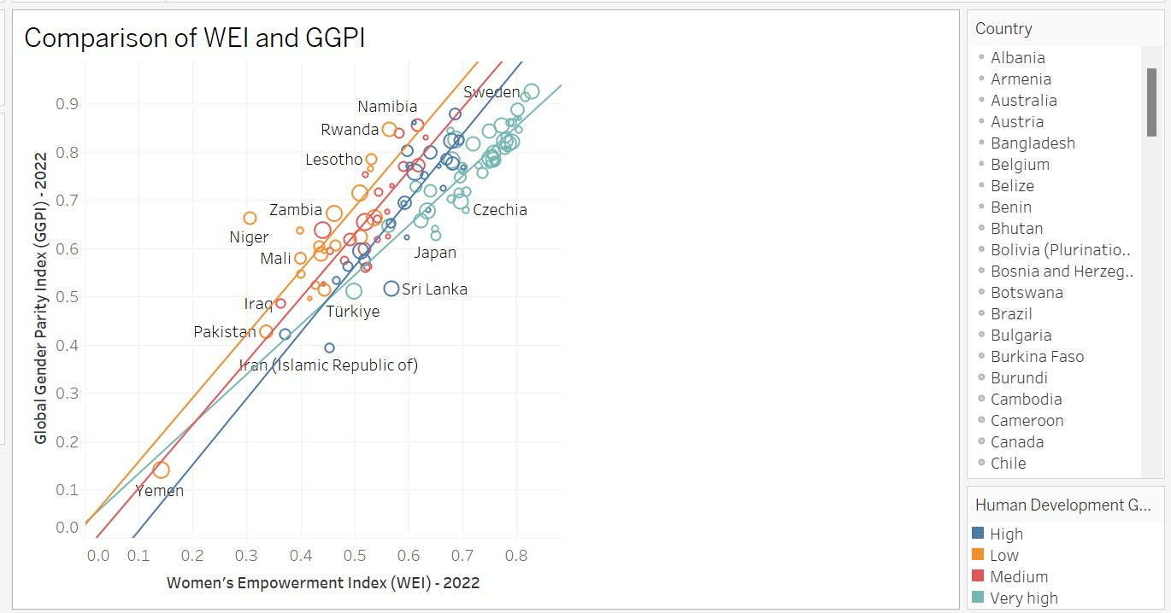

## Observations:

* + - **Positive Correlation:** The chart shows a positive correlation between the Women's Empowerment Index (WEI) and the Global Gender Parity Index (GGPI). This suggests that countries with higher WEI scores tend to also have higher GGPI scores, indicating a connection between women's empowerment and overall gender equality.
    - **Scatter and Outliers:** While there is a general trend of positive correlation, the data points are scattered, suggesting variations in the relationship between WEI and GGPI across different countries. Some countries might have higher WEI scores but lower GGPI scores, indicating that women's empowerment might not always translate directly to overall gender equality.
    - **Clustering by Human Development Group:** The chart reveals a clustering of countries based on their Human Development Group. Countries with higher Human Development Groups tend to have higher scores on both WEI and GGPI, suggesting that overall development progress is often linked to advancements in women's empowerment and gender equality.

1. 6. Comparing WEI Across Countries (Bar Chart)

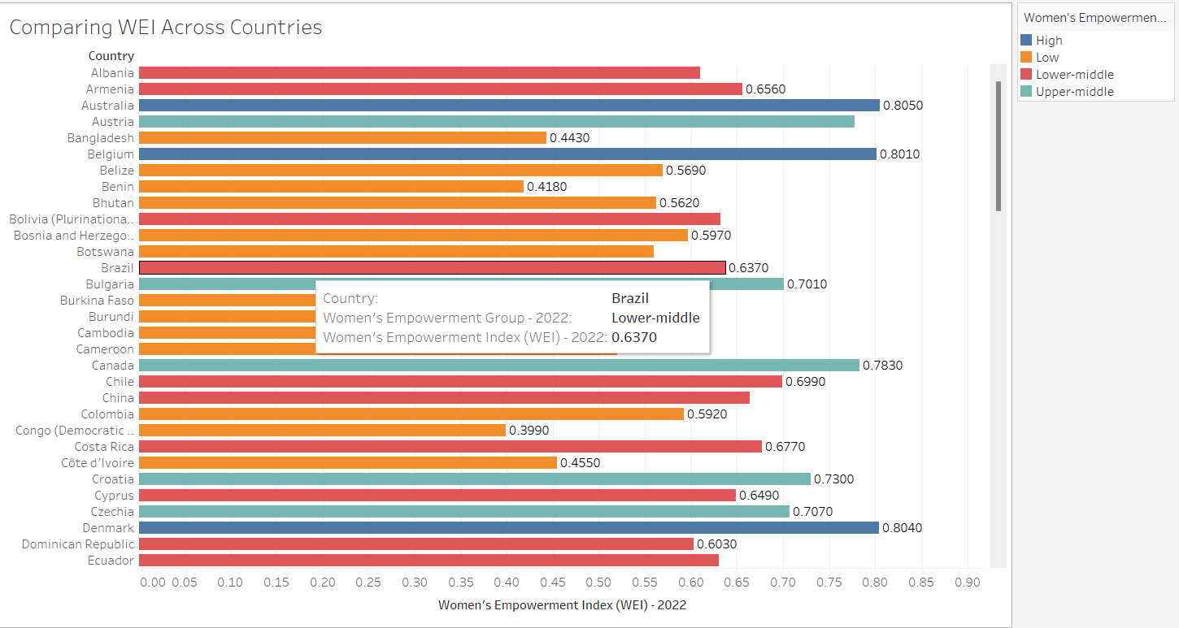

• **Purpose**: To compare the Women's Empowerment Index (WEI) or Global Gender Parity Index (GGPI) across countries.

• **Idea**: Use a bar chart to compare the WEI or GGPI scores across the listed countries. You can color-code the bars based on the "Women's Empowerment Group" or "Gender Parity Group" to show how countries are grouped.

# Dashboard:

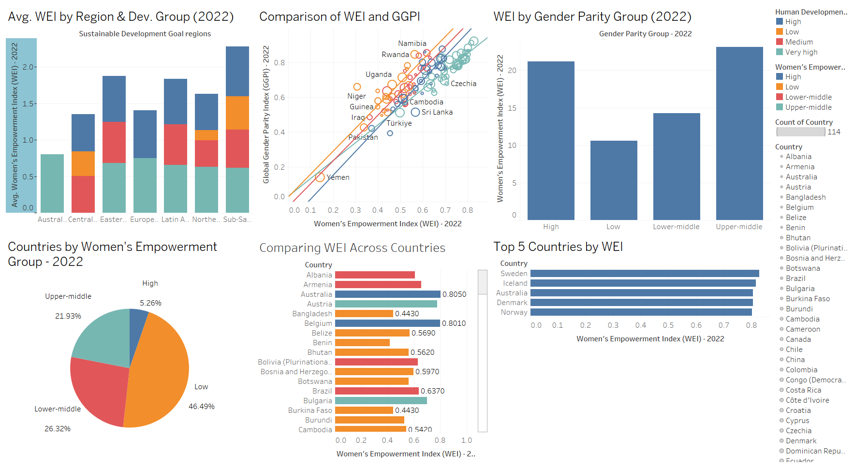

**Conclusion:**

By leveraging Tableau to visualize the Women's Empowerment Index (WEI) data, we have gained valuable insights into the global landscape of women's empowerment. The analysis reveals significant regional disparities, with Nordic countries leading in terms of women's empowerment, while regions like Sub-Saharan Africa and Northern Africa lag behind. The positive correlation between gender parity and women's empowerment emphasizes the importance of addressing gender disparities across various domains. Additionally, the analysis highlights the need for targeted interventions to promote women's empowerment in specific regions and countries. By understanding the factors influencing women's empowerment and the challenges faced by different countries, policymakers and organizations can develop effective strategies to advance women's rights and opportunities globally.